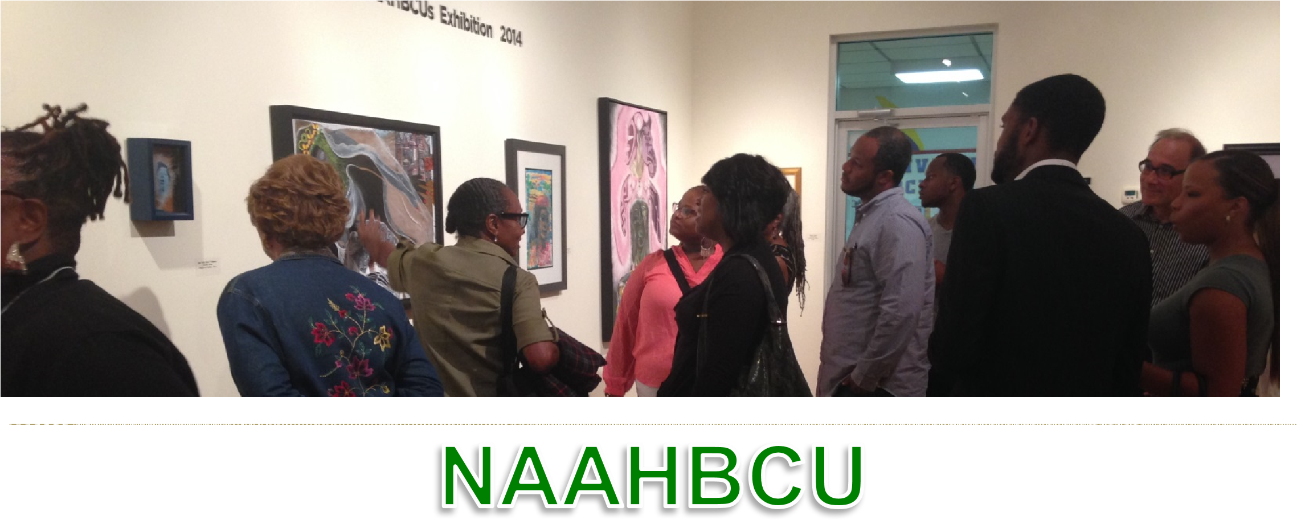
NATIONAL ALLIANCE OF ARTISTS FROM HISTORICAL BLACK COLLEGES & UNIVERSITIES
MEMBERSHIP FORM 2022-2023
Print Name: __________________________ Application Date: __________________________
Mailing Address:_____________________________________________________________
City: _________________ State: ____________ Zip: _____________________
H/O Phone: __________________ Email: ___________________ Cell: _____________________
HBCU Present or Past
Affiliate__________________________________________________________________________
Present Position: _____________________________ New Member: Yes _______ No _______
Order of Membership
Life Membership $500.00 Amount Paid: _____________ (One night free annually at any NAAHBCU designated hotel for sponsored exhibitions)
Silver Membership $300.00 Amount Paid: _____________
(50% off two nights per year in any NAAHBCU selected hotel for sponsored exhibitions)
Institutional Membership $250.00 Amount Paid: _____________
Annual Membership $50.00 Amount Paid: _____________
Student Membership $15.00 Amount Paid: _____________
Year one free to students

Please make your check out to:: The National Alliance of Artists from HBCUS

Mail this form and check to:

Yvette Brooks-Winder
245 Heritage Lake Drive
Fayetteville, GA 30214

The membership period is for one year. Membership includes newsletters, juried exhibitions and catalog conferences, job listings, and other NAAHBCU news on line at w ww.naahbcu.com.
NAAHBCU members’ art may be used for advertisement or promotion, to opt-out members must send a signed letter to NAAHBCU
The. National Alliance of Artists Headquarters: The APEX Museum, 135 Auburn Avenue,
Atlanta, GA 30303 President: Dr. Peggy Blood (912-897-2833) * Membership: Marvette P. Aldrich (336-788-37120) Bookkeeper: Yvette Brooks-Winder (678-595- 9179).

